Consommations électriques
Il faut avoir des chiffres sur les consommations électriques pour connaître les usages et planifier les économies. Je propose de construire une série de capteur, comme ceux de températures, pour suivre les consommations dans le temps
Nous allons les placer
- arrivée du château vers l'aile sud (tout ce qui a été installé il y a quelques années)
- arrivée du château vers le nouveau tableau (grenier,moitié nord pour le reste)
- atelier(s)?
- ?
Pistes:
- openenergymonitor
- https://optimalprimate.github.io/projects/2020/11/06/smart-power-meter.html
- https://how2electronics.com/iot-based-electricity-energy-meter-using-esp32-blynk/
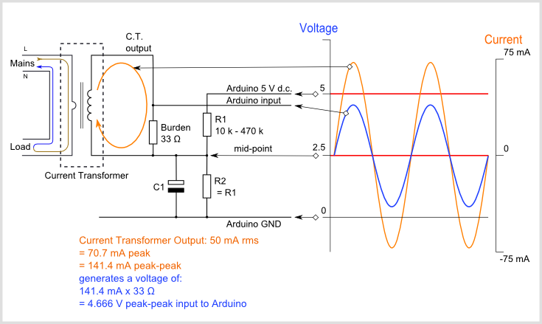
Matériel
- base esp8266
- capteur de courant SCT013 yhdc.com
- mise à niveau R 18 ou 22Ω et une capa de 10uF
- pont 2 R de 10kΩ
Code
- librairie https://github.com/openenergymonitor/EmonLib
- code de l'exemple
/*
// ESP_Wemos capteur de courant SCT013 yhdc.com
Fonction:
vérification et prise de mesures
connection sur un des reseau wifi present
se connecte au serveur MQTT
s'abonne a une possible mise a jour
poste en mqtt
deep sleep
de https://learn.openenergymonitor.org/electricity-monitoring/ct-sensors/how-to-build-an-arduino-energy-monitor-measuring-current-only
1 x CT sensor YHDC SCT-013-000
1 x Burden resistor 18 Ohms if supply voltage is 3.3V, or 33 Ohms if supply voltage is 5V
2 x 10k Ohm resistors (or any equal value resistor pair up to 470k Ohm)
1 x 10uF capacitor
3.3V
* */
#include <ESP8266WiFi.h>
#include <ESP8266WiFiMulti.h>
#include <ESP8266mDNS.h>
#include <WiFiUdp.h>
#include "EspMQTTClient.h"
#include <Ticker.h>
ESP8266WiFiMulti wifiMulti;
Ticker coucou;
char host_c[20] = "ESP-12345678"; // = ausi nom client mqtt
char host[20] = "ESP-12345678"; // maj au boot
uint64_t minute_dodo = 15; // min ESP.deepSleep(1000000 * 60 * (uint64_t)min);
String prog_version = "1";
String version_maj = "1";
unsigned long temps_milli = 0;
bool faire_maj = false;
bool demande_maj = false;
const char* ssid1 = "kerminy";
const char* password1 = "paspass";
const char* ssid2 = "NORD";
const char* password2 = "paspass";
const char* ssid3 = "SUD";
const char* password3 = "paspass";
const char* ssid4 = "BIBLIOTEQUE";
const char* password4 = "paspass";
const char* mqtt_server = "192.168.1.13";
const char* mqtt_user = "kerminy";
const char* mqtt_pass = "patate";
int mqtt_port = 1883;
bool envoie_mqtt = false;
bool connexion_prette = false;
int donnees_prette = 0;
int publie_ok = 0;
/////// METTRE NE NBR DE MQTT A POSTER !!
int publie_max = 1;
/////////////////////////////////// valeurs du msq MQTT
int retour_ok = 0; // retour du serveur
auto lastRead = millis();
EspMQTTClient client(NULL, NULL, mqtt_server, mqtt_user, mqtt_pass, host_c, mqtt_port);
void setup_wifi() {
delay(10);
// We start by connecting to a WiFi network
Serial.println();
Serial.print("Connecting to ");
Serial.print(ssid1);
Serial.print(" ");
Serial.print(ssid2);
Serial.print(" ");
Serial.print(ssid3);
Serial.print(" ");
Serial.println(ssid4);
coucou.attach(1, flip);
WiFi.mode(WIFI_STA);
wifiMulti.addAP(ssid1, password1);
wifiMulti.addAP(ssid2, password2);
wifiMulti.addAP(ssid3, password3);
wifiMulti.addAP(ssid4, password4);
int boucle = 0;
while (wifiMulti.run() != WL_CONNECTED) {
delay(500);
Serial.print(".");
if (boucle++ > 30) dodo();
}
Serial.println("");
Serial.println("WiFi connected");
Serial.println("IP address: ");
Serial.println(WiFi.localIP());
}
void onConnectionEstablished() {
connexion_prette = true ;
Serial.println("connexion MQTT PRETTE");
Serial.print(mqtt_server);
Serial.print(" ");
Serial.print(mqtt_port);
Serial.print(" ");
Serial.print(host);
Serial.print(" ");
Serial.print(mqtt_pass);
Serial.print(" ");
Serial.println(mqtt_user);
// regarde si maj firmware
String topic = "pgvrs/" ; topic += host;
client.subscribe(String(topic).c_str(), [](const String & payload) {
Serial.println(payload);
version_maj = payload;
});
coucou.attach(0.5, flip);
}
void dodo() {
digitalWrite(LED_BUILTIN, HIGH); // Turn the LED off by making the voltage HIGH
coucou.detach();
Serial.print("dodo min :");
Serial.println((float)minute_dodo);
// Connect D0 to RST to wake up !
ESP.deepSleep(minute_dodo * 60 * 1000000);
}
int count = 0;
void flip() {
int state = digitalRead(LED_BUILTIN); // get the current state of GPIO1 pin
digitalWrite(LED_BUILTIN, !state); // set pin to the opposite state
++count;
// when the counter reaches a certain value, start blinking like crazy
if (count == 20) {
coucou.attach(0.1, flip);
}
// when the counter reaches yet another value, stop blinking
else if (count == 120) {
coucou.detach();
}
}
////////////////////// SCT013 /////////////////
#include "EmonLib.h"
EnergyMonitor emon1;
double courant = 0;
void setup_SCT013()
{
emon1.current(1, 111.1); // Current: input pin, calibration.
}
void loop_SCT013()
{
double Irms = emon1.calcIrms(1480); // Calculate Irms only
Serial.print(Irms * 230.0); // Apparent power
Serial.print(" ");
Serial.println(Irms); // Irms : Valeur efficace
courant = Irms * 230.0;
envoie_mqtt = true;
}
///////////////////////////////////////////////////
void setup() {
temps_milli = millis();
pinMode(LED_BUILTIN, OUTPUT); // Initialize the LED_BUILTIN pin as an output
digitalWrite(LED_BUILTIN, LOW); // Turn the LED on (Note that LOW is the voltage level
setup_SCT013();
// Connect D0 to RST to wake up
pinMode(D0, WAKEUP_PULLUP);
Serial.begin(115200);
coucou.attach(2, flip);
Serial.println("");
Serial.print("prog_version:");
Serial.println(prog_version);
Serial.print("ChipID : ");
Serial.println(ESP.getChipId(), HEX);
sprintf(host, "ESP-%08X", ESP.getChipId());
setup_wifi();
Serial.println(host);
strlcpy(host_c, host, sizeof(host_c));
}
void loop()
{
unsigned long now = millis();
Serial.print("DEPUIS ");
Serial.println((now - temps_milli) / 1000);
if (version_maj != prog_version) {
Serial.println("version_maj en attente ");
Serial.println(version_maj);
faire_maj = true;
if (demande_maj != true ) client.enableHTTPWebUpdater(); // Enable the web updater.
// User and password default to values of MQTTUsername and MQTTPassword.
//These can be overrited with enableHTTPWebUpdater("user", "password").
demande_maj = true;
}
envoie_mqtt = false;
///
loop_SCT013();
///////// MQTT config ////////////
if (envoie_mqtt == true )
{
//EspMQTTClient client(NULL, NULL, mqtt_server, mqtt_user, mqtt_pass, host, mqtt_port); //
client.enableDebuggingMessages(); // Enable debugging messages sent to serial output
client.loop();
if (now - temps_milli > 60000) {
Serial.println("pas d'acces au serveur MQTT , dodo min :");
dodo();
}
if (now - temps_milli > 20000) { // attend 20s avant de faire
Serial.print("ATTEND CLIENT MQTT...sur ");
if ( faire_maj == true) Serial.println(WiFi.localIP());
if (connexion_prette == true ) {
Serial.println("PUBLIE");
coucou.attach(0.3, flip);
String topic = "pgvrs/"; topic += host;
if ( client.publish(String(topic).c_str(), String(prog_version).c_str() ) ) publie_ok++;
///////
topic = "courant/SCT013/" ; topic += host;
if ( client.publish(String(topic).c_str(), String(courant).c_str() ) ) publie_ok++;
dodo();
}
}
delay(1000);
}
delay(1000);
}

